**Ideation Phase**

**Brainstorm & Idea Prioritization Template**

|  |  |
| --- | --- |
| Date | 29 April 2023 |
| Team ID | NM2023TMID22230 |
| Project Name | Project - SQUID: Street Quality Identification |
| Maximum Marks | 4 Marks |

[**https://app.mural.co/t/shruthi7692/m/shruthi7692/1682930031369/1ba2da111bd4f1e33cd85ff883edbd2a6fad8933?sender=u4170e50ac73941020b7a1236**](https://app.mural.co/t/shruthi7692/m/shruthi7692/1682930031369/1ba2da111bd4f1e33cd85ff883edbd2a6fad8933?sender=u4170e50ac73941020b7a1236)

**Step-1: Team Gathering, Collaboration and Select the Problem Statement**

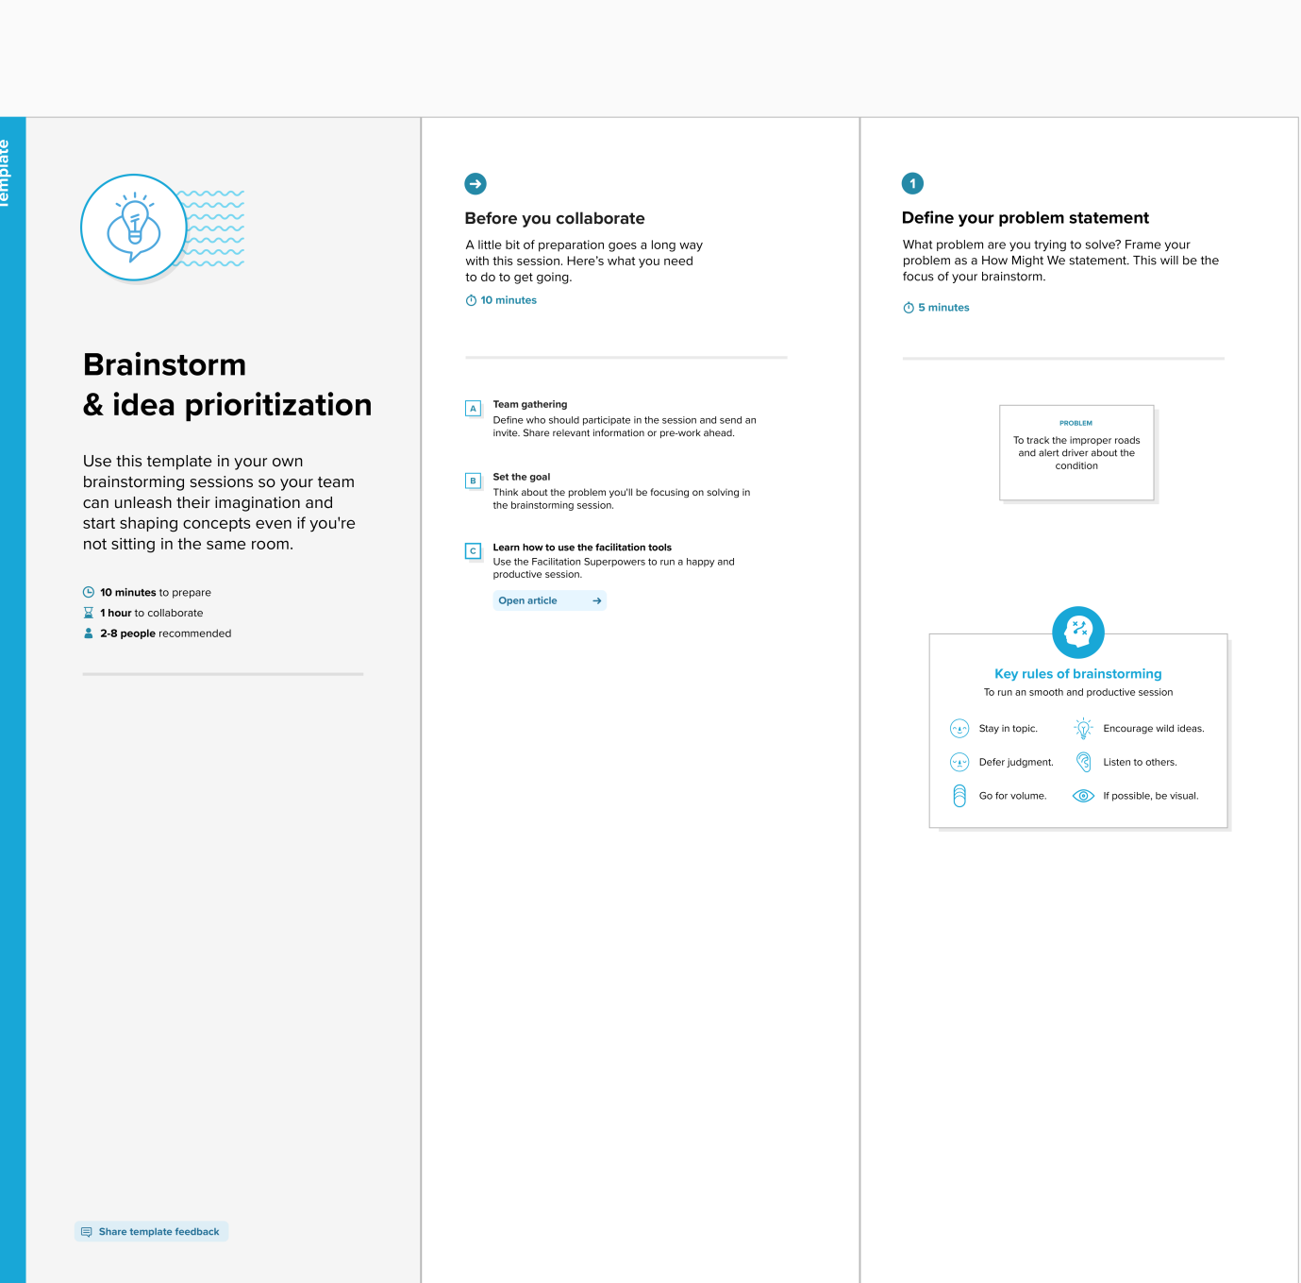

**Step-2: Brainstorm, Idea Listing and Grouping**

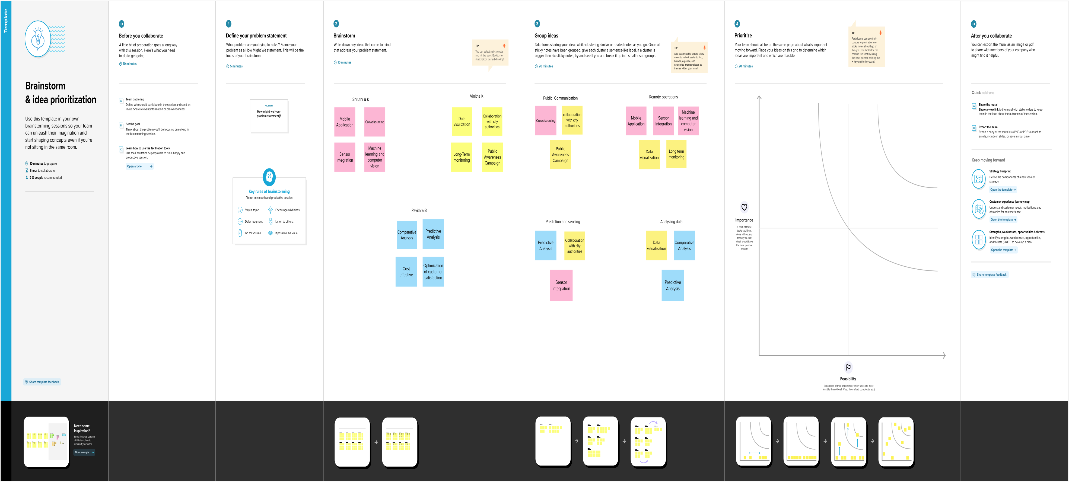

**Step-3: Idea Prioritization**

